**PARISH DATES**

**Monday 11th Sept. 7.30pm PCC Meeting in the Lodge**

**Tuesday 12th Sept. 10.15am Holy Communion in the Lodge.**

**7.30pm Men’s Group Meeting in the Village Hall**

**A talk by Alan Taylor on Water – The Elixir of Life.**

**Wednesday 13th Sept. 9.30am-11.30am ST MICHAEL’S LITTLE ANGELS**

**Sunday 17th Sept. 9.00am Holy Communion**

**10.30am Parish Communion with Sunday School**

**3.30pm CELEBRATION OF MARRIAGE WITH**

**BISHOP JILL DUFF (Followed by Bubbly and Cake)**

**Monday 18th Sept. 7.30pm Next Steps in the Bible 2 in the Lodge**

**Tuesday 19th Sept. 10.15am Holy Communion in the Lodge.**

**7.30pm Ladies Group Meeting in the Village Hall**

**Wednesday 20th Sept. 9.30am-11.30am ST MICHAEL’S LITTLE ANGELS**

**Sunday 24th Sept. 9.00am Holy Communion**

**10.30am Morning Worship with Sunday School.**

**Tuesday 26th Sept. 10.15am Morning Worship in the Lodge.**

**Wednesday 27th Sept. 9.30am-11.30am ST MICHAEL’S LITTLE ANGELS**

**Friday 29th Sept. 9.00am St Michael’s School Harvest, followed by**

**McMillan Coffee Morning in School.**

**7.00pm Harvest Social and Quiz in the Village Hall**

**Sunday 1st Oct. 9.00am Holy Communion**

**10.30am HARVEST THANKSGIVING SERVICE.**

**Monday 2nd Oct. 7.30pm Next Steps in the Bible 3 in the Lodge**

**Tuesday 3rd Oct. 10.15am Holy Communion in the Lodge.**

**Wednesday 4th Oct. 9.30am-11.30am ST MICHAELS LITTLE ANGELS**

**Thursday 5th Oct. 11.30am Wedding of Lauren and Daniel.**

**FUTURE DATES FOR YOUR DIARY:**

**SEPTEMBER 29th 7.00pm - Harvest Social and Quiz – Village Hall**

**OCTOBER 1st 10.30am- Harvest Thanksgiving Service**

**NOVEMBER 5th 6.00pm - Service of Thanksgiving for Loved Ones**

**NOVEMBER 11th 10.00 - 2.00 – Parish Quiet Day at Whalley Abbey**

**GET YOUR HARVEST SOCIAL TICKETS TODAY – Sept 29th 7.00pm IN THE VENUE**

[**www.hooleparishchurch.com**](http://www.hooleparishchurch.com)Facebook : **St Michael and All Angels Church, Hoole**,

Rector Ann Templeman anntempleman@live.co.uk 01772 448515 or 07877659156

***PLEASE TAKE THIS SHEET HOME WITH YOU.***

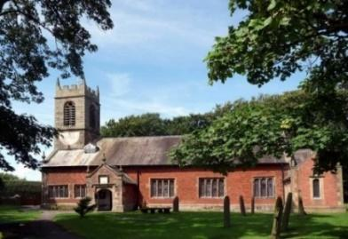

Welcome to our Church today. Please stay for refreshments

in the Lodge which follow the 10.30am service.

***Sunday 10th September 2023***

**THE GOSPEL ADVANCES**

***For to me, to live is Christ and to die is gain.*** *(Philippians 1: v 21).*

**PRAYER OF THE DAY Merciful God, your Son came to save us**

**and bore our sins on the cross: may we trust in your mercy and know**

**your love, rejoicing in the righteousness that is ours through**

**Jesus Christ our Lord. Amen.**

** No Sunday School today during the service.**

There are toys and colouring sheets for younger children

at the back of church.

**9.00am. Holy Communion (Book of Common Prayer) begins p237**

**10.30am. Parish Communion.**

**Reading: Philippians 1: v 12-26.**

**Hymns: 489 – O God beyond all praising.**

**Canticle 2 – O bless the God of Israel.**

**45 – As the deer pants for the water.**

**297 – How sweet the name of Jesus sounds.**

**205 – Glorious things of thee are spoken (tune 2).**

**3.45pm. HOGWARTS FAMILY CHURCH IN CHURCH.**

**Bible Readings:** Mon 11th Sept. Luke 6: v 6-11. Tues 12th Sept. Luke 6: v 12-19.

Wed. 13th Sept. Luke 6: v 20-26. Thursday 14th Sept. John 3: v 13-17.

Friday 15th Sept. Luke 6: v 39-42. Saturday 16th Sept. Luke 6: v 43-end.

**Reading: THE GOSPEL ADVANCES *Philippians 1: v 12-26.***

Now I want you to know, brothers and sisters, that what has happened to me has actually served to advance the gospel. As a result, it has become clear throughout the whole palace guard and to everyone else that I am in chains for Christ. And because of my chains, most of the brothers and sisters have become confident in the Lord and dare all the more to proclaim the gospel without fear.

It is true that some preach Christ out of envy and rivalry, but others out of goodwill. The latter do so out of love, knowing that I am put here for the defence of the gospel. The former preach Christ out of selfish ambition, not sincerely, supposing that they can stir up trouble for me while I am in chains. But what does it matter? The important thing is that in every way, whether from false motives or true, Christ is preached. And because of this I rejoice.

Yes, and I will continue to rejoice, for I know that through your prayers and God’s provision of the Spirit of Jesus Christ what has happened to me will turn out for my deliverance. I eagerly expect and hope that I will in no way be ashamed, but will have sufficient courage so that now as always Christ will be exalted in my body, whether by life or by death. For to me, to live is Christ and to die is gain. If I am to go on living in the body, this will mean fruitful labour for me.

Yet what shall I choose? I do not know! I am torn between the two: I desire to depart and be with Christ, which is better by far;but it is more necessary for you that I remain in the body. Convinced of this, I know that I will remain, and I will continue with all of you for your progress and joy in the faith, so that through my being with you again your boasting in Christ Jesus will abound on account of me.

**BIBLE FOR BEGINNERS**

**CONTINUES fortnightly in SEPTEMBER & OCTOBER**

**MONDAYs 7.30pm in the LODGE**

**We looked last week at the excellent portrayal of the story of Jesus and the woman at the well from the biblical film series The Chosen . If you missed it go to youtube** [**https://youtu.be/el7dzoNV3IY**](https://youtu.be/el7dzoNV3IY) **and you won’t be disappointed. Next session will be on Monday 18th Sept**

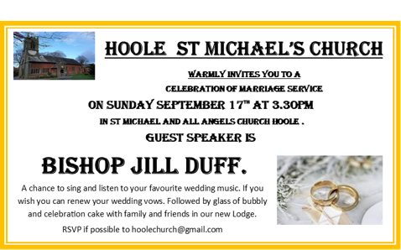

**Prayer:**  We pray for those who are sick especially, Erica Ivy, Jean Smallwood, Jon Slinger, Kathleen Smalley, Nick and Marilyn Winter, Andy Shaw, Bill & Beryl Carr. We give thanks for the lives of Gerry McCormick, Edith Chadwick & David Boston & pray for their families & friends.

