**Parish Dates September 2021 onwards**

Monday Sept 13th 7.30pm Bible Study at the Rectory.

Tuesday Sept 14th 9.00am Service for New starters and parents, and other family members too,

10.15am – 10.45am Holy Communion - Prayer time in Church.

**Saturday Sept 18th 3.00-5.00pm Clay Pigeon Shooting Party: see inside.**

**Sunday Sept 19th 09.00am Holy Communion**

**10.30am Parish Communion with Sunday School and**

**baptism of Miran Jensen (Grandchild of Mandy Hughes)**

**12.00noon Baptism of Nancy Gladwinfield.**

**4.00pm Holy Communion at Old Mill Court**

Tuesday Sept 21st 10.15am – 10.45am Prayer time in Church.

11.45am. – Funeral service of Mary Johnson.

7.30pm Bible Study at the Rectory

Thursday Sept 23rd from 11.30am Locals’ Lunch in New Village Hall

**Sunday Sept 26th h 9.00am Holy Communion**

**10.30am Morning Worship**

**12.00noon Baptism of Elijah-John Fiddler**

Monday Sept 27th 7.30pm Bible Study at the Rectory

Tuesday Sept 28th 10.15am – 10.45am Prayer time in Church.

**Key Future Dates SAVE THE DATE Harvest Festival and Social**

**Friday Oct 1st 7.00PM HARVEST SOCIAL WITH QUIZ , MEAL**

**AND ENTERTAINMENT IN THE NEW VILLAGE HALL.**

**Sunday Oct 3rd 10.30am HARVEST FESTIVAL**

**Suggested Bible readings this week**

Monday 13th Sept. Luke 7: v 1-10. Tuesday 14th Sept. John 3: 13-17.

Wednesday 15th Sept. Luke 7: v 31-35. Thursday 16th Sept. Luke 7: v 36-end.

Friday 17th Sept. Luke 8: v 1-3. Saturday 18th Sept. Luke 8: v 4-15.

**Website :** **www.hooleparishchurch.com**

Facebook page: **St Michael and All Angels Church, Hoole**,

Rector – Revd Ann Templeman anntempleman@live.co.uk 01772 448515The Rectory, 69 Liverpool Old Road Much Hoole PR4 4RB

*Please take this sheet home with you*

**St. Michael and All Angels – Hoole**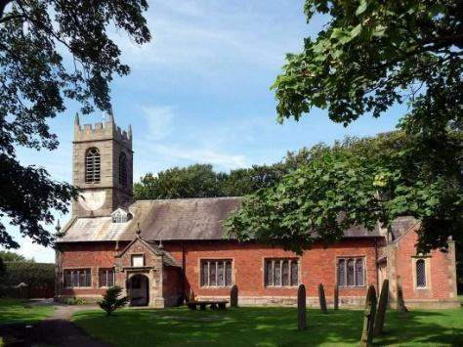

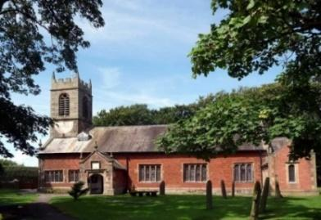

***Welcome to our church again this morning. We continue to welcome new friends and welcome back others, please stay for a chat and a cup of tea***

***or coffee after the 10.30 service, a great way to meet people.***

***Sunday 12th September 2021 Trinity 15***

**JESUS – THE KING WHO CAME TO DIE**

**Jesus asked “Who do you say that I am?”**

**Peter answered “You are the Christ”.***Mark 8 v 29*

**PRAYER OF THE DAY: Lord God, defend your Church from all**

**false teaching and give to your people knowledge of your truth,**

**that we may enjoy eternal life in Jesus Christ our Lord. Amen.**

**No Sunday School today**

**Minecraft Church at 3.45pm in school**

There are toys and colouring sheets

for younger children at the back of church.

**

**9.00am. Holy Communion (Book of Common Prayer) begins p237**

**10.30am. Morning Worship.**

**Readings: Mark 8: v 22-30. Mark 8: v 31-38.**

**Hymns: 12 – Alleluia, sing to Jesus.**

**Canticle 1 – God we praise you**

**Canticle 2 – O bless the God of Israel.**

**195 – From heaven you came (The Servant King)**

**511 – O Lord my God (How great thou art)**

**3.45pm. Minecraft Church in school.**

**BIBLE READINGS: Mark 8: v 22-30.**They came to Bethsaida, and some people brought a blind man and begged Jesus to touch him. He took the blind man by the hand and led him outside the village. When he had spat on the man’s eyes and put his hands on him, Jesus asked, ‘Do you see anything?’ He looked up and said, ‘I see people; they look like trees walking around.’ Once more Jesus put his hands on the man’s eyes. Then his eyes were opened, his sight was restored, and he saw everything clearly.  Jesus sent him home, saying, ‘Don’t even go into the village.’

Jesus and his disciples went on to the villages around Caesarea Philippi.

On the way he asked them, ‘Who do people say I am?’

They replied, ‘Some say John the Baptist; others say Elijah; and still others, one of the prophets.’ ‘But what about you?’ he asked. ‘Who do you say I am?’ Peter answered, ‘You are the Messiah.’

Jesus warned them not to tell anyone about him.

**Mark 8: v 31-38.** He then began to teach them that the Son of Man must suffer many things and be rejected by the elders, the chief priests and the teachers of the law, and that he must be killed and after three days rise again. He spoke plainly about this, and Peter took him aside and began to rebuke him. But when Jesus turned and looked at his disciples, he rebuked Peter. ‘Get behind me, Satan!’ he said. ‘You do not have in mind the concerns of God, but merely human concerns.’

Then he called the crowd to him along with his disciples and said: ‘Whoever wants to be my disciple must deny themselves and take up their cross and follow me.  For whoever wants to save their life will lose it, but whoever loses their life for me and for the gospel will save it. What good is it for someone to gain the whole world, yet forfeit their soul? Or what can anyone give in exchange for their soul? If anyone is ashamed of me and my words in this adulterous and sinful generation, the Son of Man will be ashamed of them when he comes in his Father’s glory with the holy angels.’

**Prayer.** We continue to pray for our school communities still in the early days of a new school year. We pray for Minecraft church this afternoon.

We pray that we will be able to find the money for our much needed new Lodge. On the 20th anniversary of 9/11 we pray for all who suffer as a result of war or violence and pray for peace throughout the world. We pray for those who are sick, especially Baby Erica Ivy, Patricia Mortimer, Bill and Beryl Carr, Alan Fleetwood, Nicola Middleton, Tom Parkinson & Josephine Hodge. We give thanks for the lives of Mary Johnson and Anthony Brogden and pray for their families and friends.

**TEA ROTA V**olunteers needed for tea rota after the 10.30am service. Please contact Gill Slinger on  07729121248 or gillian.slinger@ btinternet.com

**CLAY SHOOTING PARTY** to take place at 3.00pm next Saturday Sept 18th at the ‘Dolphin Clay Target Centre. £35.00 all inclusive. Contact Colin Wilson at southview1953@tiscali.co.uk or on 616978.

**BIBLE STUDIES AND PRAYER TIMES**

**Join us for Prayer time 10.15am -10.45am in church each Tuesday morning. Why not try out Bible study this autumn. We will be looking at the Parables of Jesus, starting with the Prodigal Son from Luke 15: v 11-32 on Monday 13th September, 7.30 pm at the Rectory. Please E-mail Ann if you would prefer to meet in church or by zoom.**

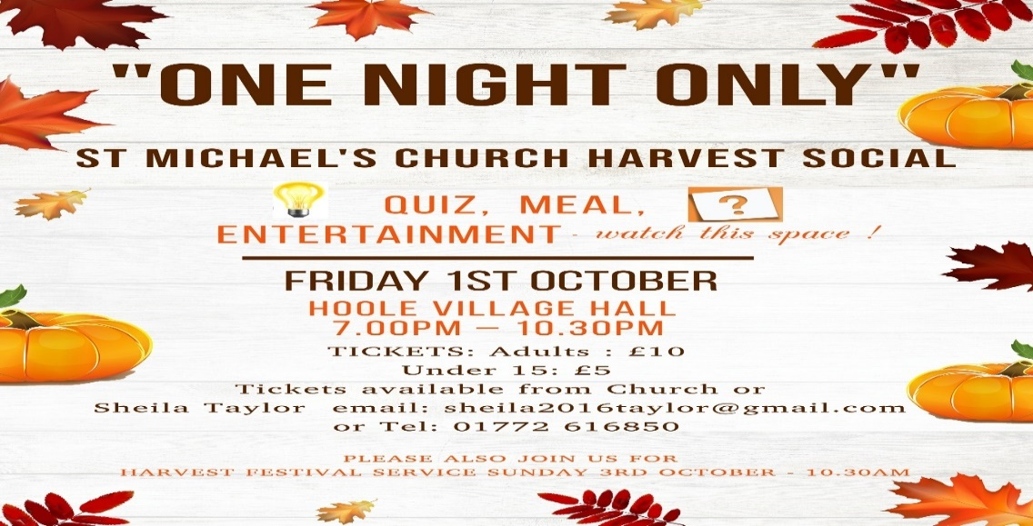

**VOLUNTEERS NEEDED TO BAKE A CAKE FOR DESSERT AT THE HARVEST SOCIAL AND/OR DONATE A RAFFLE PRIZE.**

**Please sign the list at the back of the church if you can help**