PARISH DATES
Monday 18th Sept. 7.30pm Next Steps in the Bible 2 in the Lodge
Tuesday 19th Sept. 10.15am Holy Communion in the Lodge.
7.30pm Ladies Group Meeting in the Village Hall
My Life as a Tiller Girl – Bez Cooper
Wednesday 20th Sept. 9.30am-11.30am ST MICHAEL’S LITTLE ANGELS
Sunday 24th Sept. 9.00am Holy Communion
10.30am Morning Worship with Sunday School.
Tuesday 26th Sept. 10.15am Morning Prayer in the Lodge.
Wednesday 27th Sept. 9.30am-11.30am ST MICHAEL’S LITTLE ANGELS
Friday 29th Sept. 9.00am St Michael’s School Harvest, followed by
McMillan Coffee Morning in School.
7.00pm Harvest Social and Quiz in the Village Hall
Sunday 1st Oct. 9.00am Holy Communion
10.30am HARVEST THANKSGIVING SERVICE.
Monday 2nd Oct. 7.30pm Next Steps in the Bible 3 in the Lodge
Tuesday 3rd Oct. 10.15am Holy Communion in the Lodge.
Wednesday 4th Oct. 9.30am-11.30am ST MICHAELS LITTLE ANGELS
Thursday 5th Oct. 11.30am Wedding of Lauren and Daniel.
Sunday 8th Oct. 9.00am Holy Communion
10.30am Parish Communion with Sunday School
5.00pm PIZZA’n’ PRAISE in Church
Tuesday 10th Oct. 10.15am Morning Prayer in the Lodge.
Wednesday 11th Oct. 9.30am-11.30am ST MICHAEL’S LITTLE ANGELS
Sunday 15th October 9.00am Holy Communion
10.30am Parish Communion
3.45pm Family Church in Village Hall

FUTURE DATES FOR YOUR DIARY:
SEPTEMBER 29th 7.00pm - Harvest Social and Quiz – Village Hall
OCTOBER 1st 10.30am- Harvest Thanksgiving Service
NOVEMBER 5th 4.30pm - Service of Thanksgiving for Loved Ones
NOVEMBER 11th 10.00 - 2.00 – Parish Quiet Day at Whalley Abbey

GET YOUR HARVEST SOCIAL TICKETS TODAY – Sept 29th 7.00pm IN THE VENUE
www.hooleparishchurch.com Facebook : St Michael and All Angels Church, Hoole,
Rector Ann Templeman anntempleman@live.co.uk 01772 448515 or 07877659156
PLEASE TAKE THIS SHEET HOME WITH YOU.
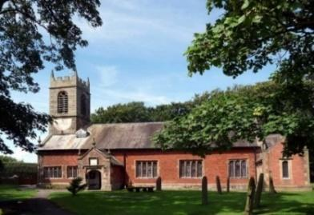
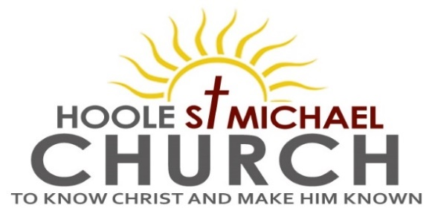

Welcome to our Church today. Please stay for refreshments
in the Lodge which follow the 10.30am service.

Sunday 17th September 2023

THE LOWLINESS AND EXALTATION OF JESUS

At the Name of Jesus every knee shall bow. (Philippians 2: v 10).

PRAYER OF THE DAY Lord God, defend your Church from all
false teaching and give to your people knowledge of your truth, that
we may enjoy eternal life in Jesus Christ our Lord. Amen.

Sunday School today during the service.
There are toys and colouring sheets for younger children
at the back of church.

9.00am. Holy Communion (Book of Common Prayer) begins p237

10.30am. Parish Communion with Sunday School.
Reading: Philippians 2: v 1-11.
Hymns: 54 – At the Name of Jesus (omit v 4).
825 – If I were a butterfly.
408 – Lord enthroned in heavenly splendour.
195 – From heaven you came.
H/C Hymns Suppl. 2 – How deep the Father’s love.
620 – Such love.

3.30pm. CELEBRATION OF MARRIAGE WITH BISHOP JILL DUFF.

Suggested Bible Readings for this week: (Thurs Matthew – Apostle & Evangelist)
Mon 18th Sept. Luke 7: v 1-10. Tues 19th Sept. Luke 7: v 11-17.
Wed. 20th Sept. Luke 7: v 31-35. Thursday 21st Sept. Matt. 9: v 9-13.
Friday 22nd Sept. Luke 8: v 1-3. Saturday 23rd Sept. Luke 8: v 4-15.
Reading: The Humility of Jesus Philippians 2: v 1-11.
Therefore if you have any encouragement from being united with Christ, if any comfort from his love, if any common sharing in the Spirit, if any tenderness and compassion, then make my joy complete by being like-minded, having the same love, being one in spirit and of one mind. Do nothing out of selfish ambition or vain conceit. Rather, in humility value others above yourselves, not looking to your own interests but each of you to the interests of the others.
In your relationships with one another, have the same mind-set as Christ Jesus: who, being in very nature God, did not consider equality with God something to be used to his own advantage; rather, he made himself nothing by taking the very nature of a servant, being made in human likeness. And being found in appearance as a man, he humbled himself
by becoming obedient to death – even death on a cross!
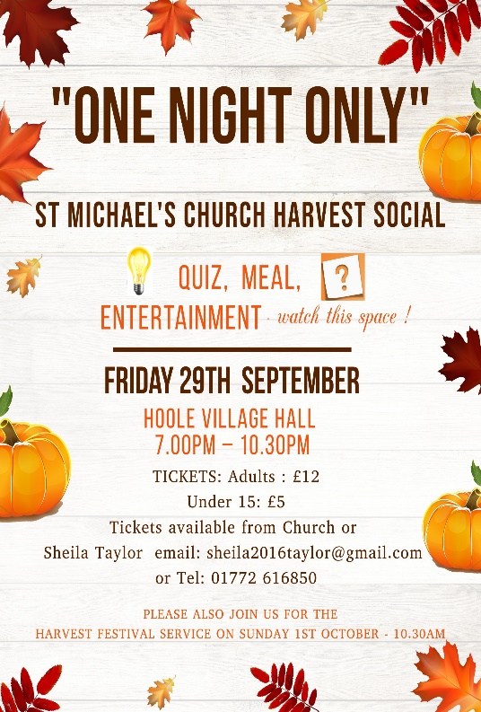
Therefore God exalted him to the highest place and gave him the name that is above every name, that at the name of Jesus every knee should bow,
in heaven and on earth and under the earth, and every tongue acknowledge that Jesus Christ is Lord, to the glory of God the Father.

Prayer: We pray for those who are sick especially, Erica Ivy, Jean
Smallwood, Jon Slinger, Bill & Beryl Carr. We give thanks for the life of David Boston & pray for his families & friends.

BIBLE FOR BEGINNERS
CONTINUES fortnightly on MONDAYs 7.30pm in the LODGE
We looked in the first week at the excellent portrayal of the story of Jesus and the woman at the well from the biblical film series The Chosen . If you missed it go to youtube https://youtu.be/el7dzoNV3IY and you won’t be disappointed. Next session will be on Monday 18th Sept

Christian Aid Walking Treasure Hunt in Longton Saturday Sept 30th and Sun Oct 1st . Enquiries Jane Stewart 613814 or Cath Greenlees 613500.

Hoole St Michael’s church
Warmly invites you to a
CELEBRATION OF MARRIAGE SERVICE
ON SUNDAY September 17th at 3.30pm
in St Michael and All Angels Church Hoole .
Guest speaker
bishop Jill Duff
A chance to sing and listen to your favourite wedding music. If you wish you can renew your wedding vows. Followed by glass of bubbly and celebration cake with family and friends in our new Lodge.

*Please send to Jean jeandew@btinternet.com

