**Parish Dates September 2021 onwards**

Monday Sept 27th 2.30pm Funeral service of Anthony Brogden.

7.30pm Bible Study at the Rectory.

Tuesday Sept 28th 10.15am – 10.45am Prayer time in Church.

Wednesday Sept 29th 4.30pm First ‘Griefshare’ session at the Rectory.

Thursday Sept 30th 4.30pm Chat and Chocolate group in Church.

**Friday Oct 1st 7.00PM HARVEST SOCIAL WITH QUIZ ,**

**MEAL AND ENTERTAINMENT**

**IN THE NEW VILLAGE HALL.**

**Sunday Oct 3rd 9.00am Holy Communion**

**10.30am HARVEST FESTIVAL SERVICE.**

Tuesday Oct 5th 10.15am – 10.45am Prayer time in Church.

7.30pm Bible Study at the Rectory.

**Sunday Oct 10th 9.00am Holy Communion**

**10.30am Morning Worship with Sunday School.**

Monday Oct 11th 7.30pm Bible Study at the Rectory.

Tuesday Oct 12th 10.15am – 10.45am Prayer time in Church.

2.45pm School Worship in Church.

Thursday Oct 14th from 11.30am Locals’ Lunch in New Village Hall.

4.30pm Chat and Chocolate group in Church.

**Sunday Oct 17th 9.00am Holy Communion**

**10.30am Parish Communion.**

**3.45pm Pokemon Church at Hoole Village Hall.**

Monday Oct 18th 3.30pm Bereavement group tea.

Tuesday Oct 19th 10.15am – 10.45am Prayer time in Church.

7.30pm Bible Study at the Rectory.

**Sunday Oct 24th 9.00am Holy Communion**

**10.30am Morning Worship with Sunday School.**

**Key Future Date.**

**Sunday Oct 31st 6.00pm SERVICE OF THANKSGIVING**

**FOR LOVED ONES.**

**Church website :** **www.hooleparishchurch.com****.**

Facebook page: **St Michael and All Angels Church, Hoole**,

Rector – Revd Ann Templeman anntempleman@live.co.uk 01772 448515The Rectory, 69 Liverpool Old Road Much Hoole PR4 4RB

*Please take this sheet home with you*

**St. Michael and All Angels – Hoole**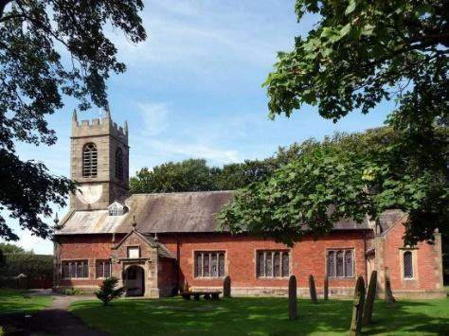

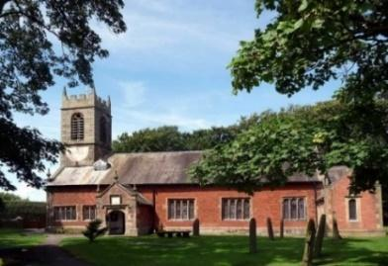

***Welcome to our church again this morning. We continue to welcome new friends and welcome back others, please stay for a chat and a cup of tea or coffee after the 10.30 service, a great way to meet people.***

***Sunday 26th September 2021 Trinity 17***

**TRUSTING JESUS**

**Then Jesus said “For such a reply you may go”. She went home and**

**found her daughter lying on the bed and the demon gone.** *Mark 7 v 29-30.*

**PRAYER OF THE DAY: Gracious God, you call us to fullness of life:**

**deliver us from unbelief and banish our anxieties with the liberating**

**love of Jesus Christ our Lord. Amen.**

**Sunday School today during the service**

There are toys for younger children

at the back of church.

**

**9.00am. Holy Communion (Book of Common Prayer) begins p237**

**10.30am. Morning Worship with Sunday School.**

**Reading: Mark 7: v 24-30.**

**Hymns: 489 – O God beyond all praising**

**Screen/video – You are shaped for serving God.**

**Suppl 9 – The Lord’s my Shepherd.**

**Suppl 5 – Bless the Lord O my soul.**

**Suppl 6 – We rest on Thee (**tune Finlandia**)**

**12.00noon. Baptism of Elijah–John Fiddler.**

**BIBLE READING: Mark 7: v 24-30.** Jesus left that place and went to the vicinity of Tyre. He entered a house and did not want anyone to know it; yet he could not keep his presence secret. In fact, as soon as she heard about him, a woman whose little daughter was possessed by an impure spirit came and fell at his feet. The woman was a Greek, born in Syrian Phoenicia. She begged Jesus to drive the demon out of her daughter.

‘First let the children eat all they want,’ he told her, ‘for it is not right to take the children’s bread and toss it to the dogs.’

‘Lord,’ she replied, ‘even the dogs under the table eat the children’s crumbs.’

Then he told her, ‘For such a reply, you may go; the demon has left your daughter.’

She went home and found her child lying on the bed, and the demon gone.

**Prayer.** We continue to pray for Miran and Nancy who were baptised last week and for Elijah-John to be baptised today. We pray for those who are sick, especially Baby Erica Ivy, Patricia Mortimer, Harriet Mitcheson, Rose Wood and Nicola Middleton. We give thanks for the lives of Mary Johnson, Anthony Brogden and Alan Fleetwood and pray for their families and friends. We give thanks for the lives of those whose anniversary falls at this time remembering today Eric Barker.

**Suggested Bible readings this week.**

Monday 27th Sept. Luke 9: v 46-50. Tuesday 28th Sept. Luke 9: v 51-56.

**Wednesday 29th Sept. The Festival of St Michael and All Angels**

**Revelation 12: v 7-12**. Thursday 30th Sept. Luke 10: v 1-12.

Friday 1st Oct. Luke 10: v 13-16. Saturday 2nd Oct. Luke 10: v 17-24.

**TEA ROTA V**olunteers needed for tea rota after the 10.30am service. Please contact Gill Slinger on  07729121248 or gillian.slinger@ btinternet.com

**BIBLE STUDIES AND PRAYER TIMES**

**THE PARABLES OF JESUS.**

**Please join us at a Home Group to look at the Bible together.**

**Monday September 27th 7.30pm at the Rectory; The Good Samaritan Luke 10v 25-37**

**Join us for Prayer time 10.15am -10.45am in church Tuesday morning**

