**Parish Dates September 2021 onwards**

Monday Sept 6th 7.30pm PCC meeting at the Rectory

Tuesday Sept 7th 10.15am – 10.45am. Prayer time in Church

7.30pm Bible Study in Rectory

Thursday Sept 9th from 11.30am Locals’ Lunch in New Village Hall

Friday Sept 10th 9.00am Beginning of term service

for whole school and parents.

**Sunday Sept 12th 9.00am Holy Communion**

**10.30am Morning Worship**

**3.45pm Minecraft Church in School.**

Monday Sept 13th 7.30pm Bible Study at the Rectory (venu tbc)

Tuesday Sept 14th 9.00am Service for new starters and parents.

10.15am – 10.45am Prayer time in Church.

**Saturday Sept 18th 3.00-5.00pm Clay Pigeon Shooting Party: see inside.**

**Sunday Sept 19th 09.00am Holy Communion**

**10.30am Parish Communion with Sunday School and**

**baptism of Miran Jensen (Grandchild of Mandy Hughes)**

**12.00noon Baptism of Nancy Gladwinfield.**

Tuesday Sept 21st 10.15am – 10.45am Prayer time in Church.

7.30pm Bible Study at the Rectory

Thursday Sept 23rd from 11.30am Locals’ Lunch in New Village Hall

**Sunday Sept 26th h 9.00am Holy Communion**

**10.30am Morning Worship**

**12.00noon Baptism of Elijah-John Fiddler**

Monday Sept 27th 7.30pm Bible Study at the Rectory

Tuesday Sept 28th 10.15am – 10.45am Prayer time in Church.

**Key Future Dates SAVE THE DATE Harvest Festival and Social**

**Friday Oct 1st 7.00PM HARVEST SOCIAL WITH QUIZ , MEAL**

**AND ENTERTAINMENT IN THE NEW VILLAGE HALL.**

**Sunday Oct 3rd 10.30am HARVEST FESTIVAL**

**An audio recording of the 10.30 service will be on the church website :** **www.hooleparishchurch.com** **this afternoon.**

Facebook page: **St Michael and All Angels Church, Hoole**,

Rector – Revd Ann Templeman anntempleman@live.co.uk 01772 448515The Rectory, 69 Liverpool Old Road Much Hoole PR4 4RB

**St. Michael and All Angels – Hoole**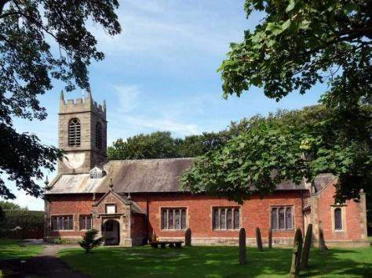

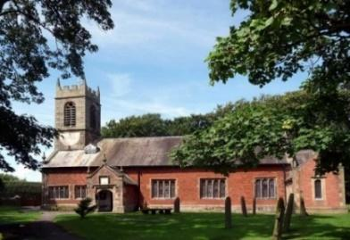

***Welcome to our church again this morning. We continue to welcome new friends and welcome back others, please stay for a chat and a cup of tea***

***or coffee after the 10.30 service, a great way to meet people.***

***Sunday 5th September 2021 Trinity 14***

***‘*JESUS CHANGES EVERYTHING’ – A NEW START**

***People were overwhelmed with amazement. ‘He has done everything well,’ they said. ‘He even makes the deaf hear and the mute speak.’*** *Mark 7 v 37*

**PRAYER OF THE DAY: Merciful God, your Son came to save us**

**and bore our sins on the cross: may we trust in your mercy and know**

**your love, rejoicing in the righteousness that is ours**

**through Jesus Christ our Lord. Amen.**

**Sunday School begins again today** We have 2 classes for different age groups.

There are also toys and colouring sheets

for younger children at the back of church.

**

**9.00am. Holy Communion (Book of Common Prayer) begins p237**

**10.30am. Parish Communion with commissioning**

**of Sunday School teachers and helpers.**

**Readings: Isaiah 35. Mark 7: v 27-31.**

**Hymns: 54 (tune 2 omitting v’s 2 & 5) At the name of Jesus.**

**Video – God Suit , 29 – Amazing Grace.**

**Supp 1 – In Christ alone.**

**766 – You shall go out with joy.**

**H/C Hymns: 620 – Such love. 738 – When I survey the wondrous cross.**

**BIBLE READINGS: Isaiah 35.**The desert and the parched land will be glad; the wilderness will rejoice and blossom. Like the crocus,it will burst into bloom; it will rejoice greatly and shout for joy…..  
Strengthen the feeble hands, steady the knees that give way; say to those with fearful hearts, ‘Be strong, do not fear; your God will come, he will come with vengeance; with divine retribution he will come to save you.’ Then will the eyes of the blind be opened and the ears of the deaf unstopped. Then will the lame leap like a deer, and the mute tongue shout for joy. Water will gush forth in the wilderness  
and streams in the desert…..  
And a highway will be there; it will be called the Way of Holiness; it will be for those who walk on that Way. The unclean will not journey on it; wicked fools will not go about on it. No lion will be there, nor any ravenous beast; they will not be found there. But only the redeemed will walk there, and those the Lord has rescued will return. They will enter Zion with singing; everlasting joy will crown their heads. Gladness and joy will overtake them, and sorrow and sighing will flee away.

**Mark 7: v 31-37.** Jesus left the vicinity of Tyre and went through Sidon, down to the Sea of Galilee and into the region of the Decapolis. There some people brought to him a man who was deaf and could hardly talk, and they begged Jesus to place his hand on him.

After he took him aside, away from the crowd, Jesus put his fingers into the man’s ears. Then he spat and touched the man’s tongue. He looked up to heaven and with a deep sigh said to him, *‘Ephphatha!’* (which means ‘Be opened!’). At this, the man’s ears were opened, his tongue was loosed and he began to speak plainly.

Jesus commanded them not to tell anyone. But the more he did so, the more they kept talking about it. People were overwhelmed with amazement. ‘He has done everything well,’ they said. ‘He even makes the deaf hear and the mute speak.’

**Prayer.** We pray for our school communities as the children return after the holidays especially St Michael’s and Little Hoole. We pray that they will be kept free from infection and that the children will be able to enjoy learning together once more. We pray for our children’s and youth work, for our Sunday school children and leaders. We pray that we will be able to find the money for our much needed new Lodge. We pray for those who are sick, especially Baby Erica Ivy, Patricia Mortimer, Bill and Beryl Carr, Alan Fleetwood, Nicola Middleton, Anthony Brogden and Josephine Hodge. We give thanks for the life of Kenneth Thomas and pray for his family and friends.

**TEA ROTA V**olunteers needed for tea rota after the 10.30am service. Please contact Gill Slinger on  07729121284 or gillian.slinger@ btinternet.com

**CLAY SHOOTING PARTY** to take place at 3.00pm on Saturday Sept 18th at the ‘Dolphin Clay Target Centre. £35.00 all inclusive. Contact Colin Wilson at southview1953@tiscali.co.uk or on 616978.

**BIBLE STUDIES AND PRAYER TIMES**

**Join us for Prayer time 10.15am -10.45am in church each Tuesday morning. Why not try out Bible study this autumn. We will be looking at the Parables of Jesus, starting with the Prodigal Son from Luke 15: v 11-32 on Tuesday 7th September, 7.30 pm at the Rectory and then again on Monday 13th Sept.**

**Please E-mail Ann if you would prefer to meet in church or by zoom.**



