PARISH DATES
Tuesday 28th May 10.15am Holy Communion in the Lodge
Wednesday 29th May NO St Michael’s Little Angels (Half term)
Friday 31st May 1.00pm Wedding of Pippa and Scott.
Sunday 2nd June Celebration of God’s Gifts – Gift Day.
Please make sure that you have a pack of how YOU can support St Michael’s.
9.00am Holy Communion
10.30am Parish Communion with Sunday School
4.00pm Holy Communion (Old Mill Court).
Monday 3rd June 2.30pm Holy Communion (Ribble Court)
7.30pm Bible for Beginners in the Lodge
Tuesday 4th June 10.15am Holy Communion in the Lodge
Wednesday 5th June 9.30am-11.00am St Michael’s Little Angels
Sunday 9th June 9.00am Holy Communion
10.30am Parish Communion with Sunday School.
Tuesday 11th June 10.15am Morning Prayer in the Lodge
Wednesday 12th June 9.30am-11.00am St Michael’s Little Angels
Sunday 16th June 9.00am Holy Communion
10.30am Morning Worship with Sunday School.
Tuesday 18th June 10.15am Morning Prayer in the Lodge
Wednesday 19th June 9.30am-11.00am St Michael’s Little Angels
Thursday 20th June 2.00pm Ladies Group meet in the Village Hall.
Sunday 23rd June 9.00am Holy Communion
10.30am Morning Worship.
3.45pm GLADIATORS FAMILY CHURCH
in St. Michael’s School – for all the family.
Monday 24th June 7.30pm Bible for Beginners in the Lodge
Tuesday 25th June 10.15am Holy Communion in the Lodge
Wednesday 26th June 9.30am-11.00am St Michael’s Little Angels
Sunday 30th June 9.00am Holy Communion
10.30am Parish Communion with Sunday School.
5.00pm Pizza ‘n Praise in Church and Lodge.

BIBLE FOR BEGINNERS with clips from the CHOSEN
Continues on Monday 3rd June at 7.30pm in the Lodge then fortnightly

www.hooleparishchurch.com Facebook : St Michael and All Angels Church, Hoole,
Rector Ann Templeman anntempleman@live.co.uk 01772 448515 or 07877659156
PLEASE TAKE THIS SHEET HOME WITH YOU.
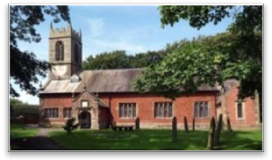


Welcome to our Church today.
Please stay for refreshments in the Lodge which follow the 10.30am service.

Sunday 26th May 2024 Trinity

GIVING IN GRACE – THY KINGDOM COME

Jesus said “She has done a beautiful thing to me” (Mark 14: v 6)

PRAYER OF THE DAY Holy God, faithful and unchanging: enlarge
our minds with the knowledge of your truth, and draw us more deeply
into the mystery of your love, that we may truly worship you,
Father, Son and Holy Spirit, one God, now and for ever. Amen

Sunday School today during the service.
toys and colouring sheets for younger children
at the back of church.

9.00am. Holy Communion (Book of Common Prayer p237)
10.30am. Morning Worship with Sunday School.
Readings: Psalm 23.
Mark 14: v 1-11.
Hymns: 286 – Holy, holy, holy! Lord God almighty.
Screen – Every move I make.
649 – The King of love my shepherd is (tune 2).
18 – All I once held dear.
727 – What a friend we have in Jesus.

5.00pm: Pizza ‘n Praise in Church and Lodge.

Suggested Bible readings for this week:
Monday 27th May Mark 10: v 17-27. Tuesday 28th May Mark 10: v 28-31.
Wednesday. 29th May Mark 10: v 32-45. Thursday 30th May Mark 10: v 46-end. Friday 31st May Mark 11: v 11-26. Saturday 1st June Mark 11: v 27-end.
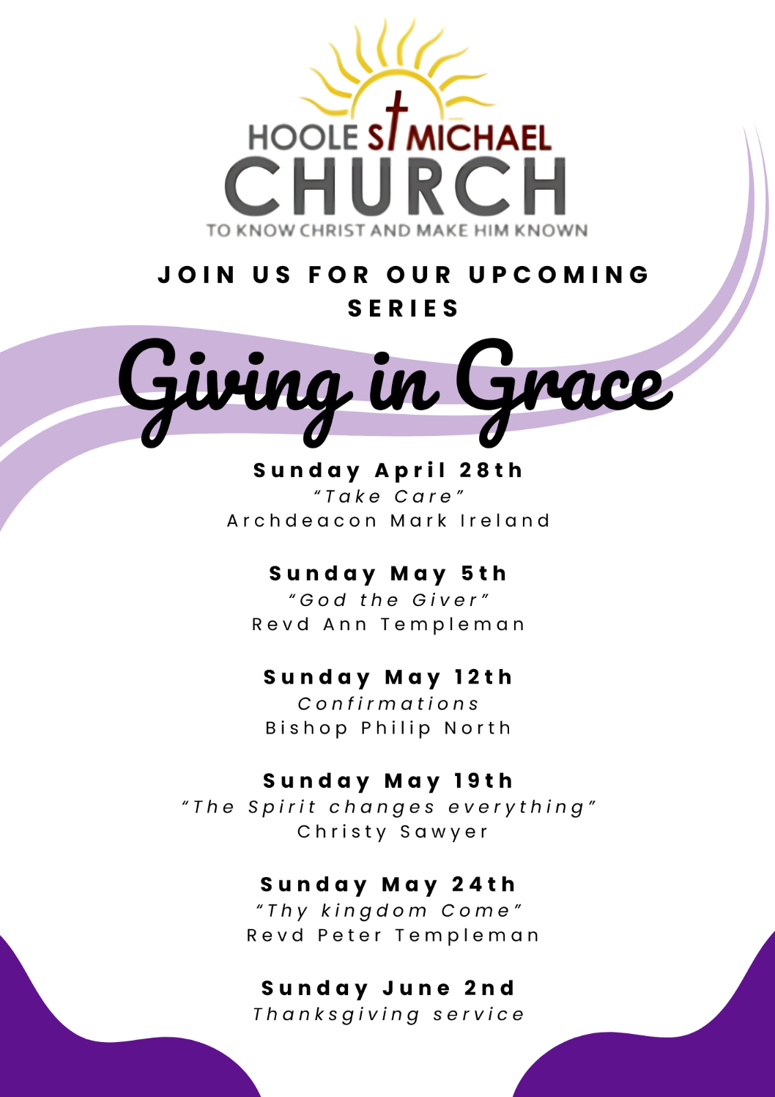
Bible Reading 1: Psalm 23.
The Lord is my shepherd, I lack nothing. He makes me lie down in green pastures, he leads me beside quiet waters, He refreshes my soul.
He guides me along the right paths for his name’s sake.
Even though I walk through the darkest valley, I will fear no evil,
for you are with me; your rod and your staff, they comfort me.
You prepare a table before me in the presence of my enemies.
You anoint my head with oil; my cup overflows.
Surely your goodness and love will follow me all the days of my life,
and I will dwell in the house of the Lord forever.

Bible Reading 2: Jesus anointed at Bethany. Mark 14: v 1-11.
Now the Passover and the Festival of Unleavened Bread were only two days away, and the chief priests and the teachers of the law were scheming to arrest Jesus secretly and kill him. ‘But not during the festival,’ they said, ‘or the people may riot.’
While he was in Bethany, reclining at the table in the home of Simon the Leper, a woman came with an alabaster jar of very expensive perfume, made of pure nard. She broke the jar and poured the perfume on his head.
Some of those present were saying indignantly to one another, ‘Why this waste of perfume? It could have been sold for more than a year’s wages^{[a]} and the money given to the poor.’ And they rebuked her harshly.
‘Leave her alone,’ said Jesus. ‘Why are you bothering her? She has done a beautiful thing to me. The poor you will always have with you, and you can help them any time you want. But you will not always have me. She did what she could. She poured perfume on my body beforehand to prepare for my burial. Truly I tell you, wherever the gospel is preached throughout the world, what she has done will also be told, in memory of her.’
Then Judas Iscariot, one of the Twelve, went to the chief priests to betray Jesus to them. They were delighted to hear this and promised to give him money. So he watched for an opportunity to hand him over.

Prayer We pray for our church and the ‘Giving in Grace’ series of services. We continue to pray for all those affected by the conflicts in the troubled areas of the world. We continue to pray for those recently confirmed as they approach their first Communion service. We pray for Pippa and Scott to be married on Friday. We pray for the sick, especially Sue Meadows, Nick Slinger, Ben Allen, Edward Kenyon, Judith Stopford and Elaine Read.

PRAY FOR OUR CHURCH
Please come and join us for Prayer for the future of our church on Tuesdays in the Lodge at 10.15 during our service of Holy Communion

